

National Technical University of Ukraine "Igor Sikorsky Kyiv Polytechnic Institute”


SOFTWARE SYSTEM DESIGN PROJECT

prepared by :-Solomon Abrha

sub.To Ruslan

Table of Contents
Chapter one 3
Introduction 3
Requirements and Analysis 3
Import export 4
Operations 5
operation types 5
Matrix subtraction 5
Error conditions 6
Matrix multiplication 7
Error conditions 8
Matrix Transpose 8
Matrix Insertion sort 9
Array Insertion sort 11
Results 12

list of Drawings
Drawing 1: process.argv 4
Drawing 2: File structure 4
Drawing 3: Export File 5
Drawing 4: Importing functions 5
Drawing 5: subtraction function 6
Drawing 6: matrix with one element missing 7
Drawing 7: result of unequal matrix 7
Drawing 8: Error return for unequal matrices 8
Drawing 9: Matrix multiply function 9
Drawing 10: matrix transpose function 10
Drawing 11: function to convert two dimensional array to one 10
Drawing 12: insertion sorting 11
Drawing 13: function to concert one dimensional array to two 11
Drawing 14: if function for second position in insertion sort 12
Drawing 15: insertion sorting of array 12
Drawing 16: subtraction result 13
Drawing 17: Matrix multiply result 14
Drawing 18: Two- Matrix insertion result 14
Drawing 19: One-Matrix insertion 15
Drawing 20: Array-Insertion 15

Chapter one

Introduction
The programming language used for the course is java Script. So along with is let fs=require(`fs`) module was used. The project uses command line argument to execute a tasks. The tasks are to be executed are as listed. Matrix operation; multiplication , transpose ,subtract and insertion sorting
The whole project is have four different files. The main file app,js which main program is taking place, the function file fun.js which handles all the function running on the app.js. The fun.js and the app.js are linked with export and import methods.
Command line argument; process.argv is an array of two elements initially. With the file directory to node environment and and the file directory.
Drawing 1: process.argv

Requirements and Analysis
For the project there are four different files
app.js

{operations and
Function import
}

Function files
{all functions
Operating on
app.js are exported

Drawing 2: File structure
Json files

matrix1.json
&
matrix2.json

And the other library imported is file system which is written with the following syntax
let fs = require(`fs`)

Import export
The program run on two main parts which are linked with import and export method. All the functions in the fun.js file are exported to app.js as shown in the Drawing 3 below.
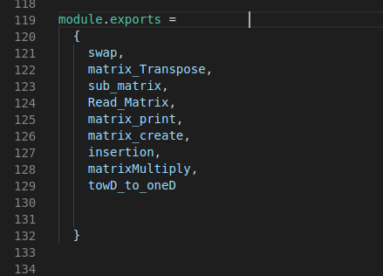Drawing 3: Export File

module.exports=
{
//all methods and functions to be exported
}
the exported files are again imported to where needed in this case to app.js. And how to import is shown on Drawing 4 below
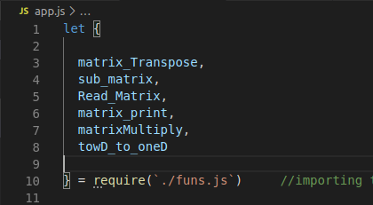Drawing 4: Importing functions

Operations
All operations on the program are performed on matrix. The command to are as follows:
- node app.js matrix `operation type` files(./matrix1.json ./matrix2.json)

operation types

Matrix subtraction
- The command (node app.js matrix sub./matrix1.json ./matrix2.json)
Matrix subtraction uses two matrix files to output the difference. The function for the operation is as follows
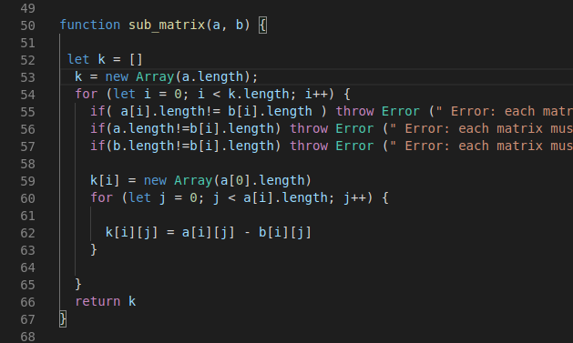Drawing 5: subtraction function
The function operates first by creating an empty matrix “k” by equating the width and length to one of the matrix
let k= [] // this declaration will create new array
k=new Array(a.length) // this will equate number of rows of new ‘K’ array to a’s
Again equate the number of columns of new array ‘K’ to a’s by k[i]=a[0] in side the first loop.
Therefore at this stage there will be new empty matrix with number of rows and columns equal to `matrix a`.
Again create a nested loop for the to execute the operation k[i][j] = a[i][j] - b[i][j]
and populate the new matrix ‘K[i][j]’ with the result of the operation

Error conditions
For subtraction operation to be execrated the two matrices must be equal to each other and as for the our case needs to be square.
if( a[i].length!= b[i].length ) throw Error (" Error: each matrix must be square with equal size in between => n X n and m X m n=m ")
if(a.length!=b[i].length) throw Error (" Error: each matrix must be square with equal size in between => n X n and m X m n=m ")
if(b.length!=b[i].length) throw Error (" Error: each matrix must be square with equal size in between => n X n and m X m n=m ")

The above there conditions must be satisfied for the function to execute. Not only the size of the matrix but quantitative number of elements must be at the same amount.
To illustrate the above statement the following drawing added
case one:- missing one element
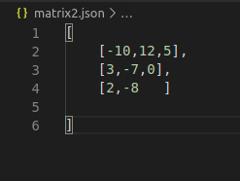Drawing 6: matrix with one element missing

on the above matrix element [3][3] is missing and the result for the subtraction will be as follows. The logical scenes here is to expect error. Because not only number of columns and row must be equal to each other but also quantitative amount of each elements as well
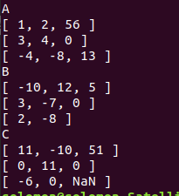Drawing 7: result of unequal matrix

On the place of the missing element the program console out NaN(not a number). So there should be an error condition for it as well.
The result after the stating the Error condition is:-
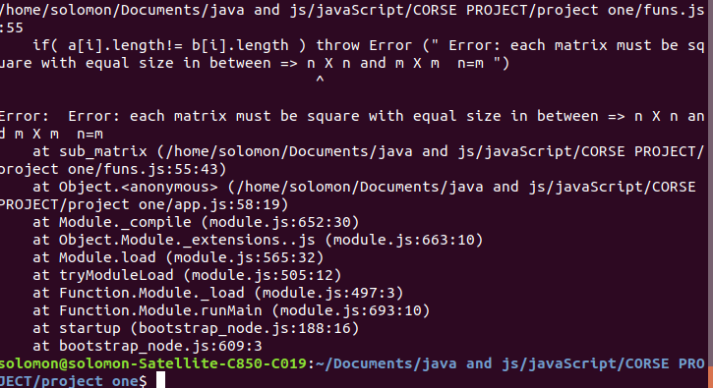Drawing 8: Error return for unequal matrices
The error states that `each matrix must be square with equal size in between =>nXn and mXm where n=m
case two:- missing one row
As stated on the beginning the two matrices must have equal number of rows and columns with both being square.

Matrix multiplication
- The command (node app.js matrix multiply ./matrix1.json ./matrix2.json)
Multiplication of a matrix is operated on two different matrices having the number of column of the first matrix equal to the number of row of the second matrix.
Matrix multiply is also executed with the same method as subtraction with creating new empty matrix
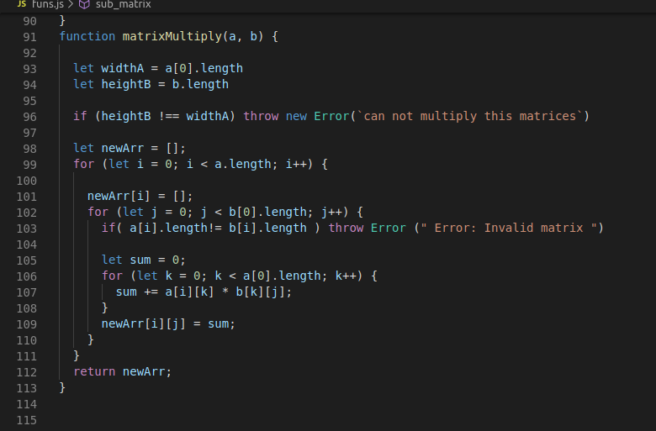Drawing 9: Matrix multiply function
for multiplication function three nested loops are needed

Error conditions
Matrix multiply conundrum have the same error conditions with subtraction

Matrix Transpose
- The command (node app.js matrix transpose ./matrix1.json or ./matrix2.json)
Transpose of a matrix is a new matrix whose rows are the columns of the original. (This makes the columns of the new matrix the rows of the original).
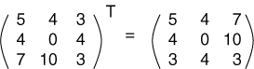
The function to Transpose matrix operates by creating a new empty matrix.
After creating the matrix set the dimension to it to the original matrix.
`matrix_create` function is called here and height and width of the original matrix passed. This will set the dimension of the new matrix with the original matrix ‘m’.
The Error condition here is to check if the original matrix is square or not.
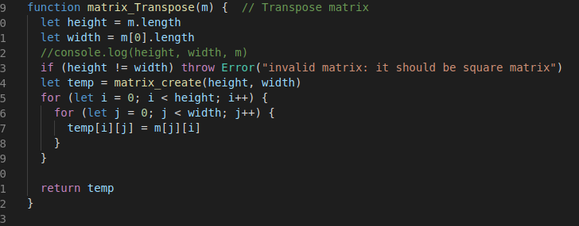Drawing 10: matrix transpose function

Matrix Insertion sort
- The command (node app.js matrix multiply ./matrix1.json ./matrix2.json)
- The command (node app.js matrix multiply ./matrix1.json or ./matrix2.json)
The insertion algorithm sort the matrix value to increasing order. This operation undergoes three major steps.
Step 1:- changing the two dimensional array to one dimension.
The very firs step was to crate one dimensional empty array and populate the elements of the array in one line
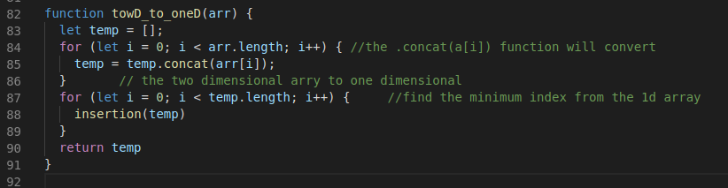Drawing 11: function to convert two dimensional array to one
let tmp= [] this declaration will create a new empty array
and inside the for loop setting the “temp =temp.concat(arr[i]) will covert the two dimensional array to one dimension and set the elements to the new array.
After converting the array the next step will be to sort the elements by insertion sorting method.
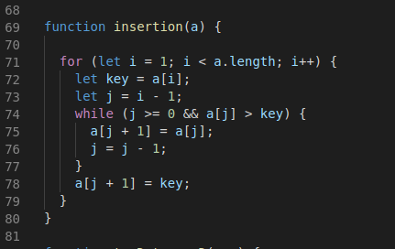Drawing 12: insertion sorting

The when passing the array thorough this function the array will be sorted to increasing order.
After sorting the array will again be converted to two dimensional array again by the following method
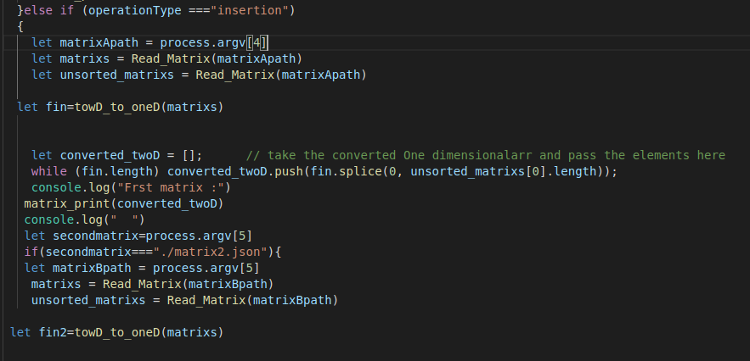Drawing 13: function to concert one dimensional array to two
the process.agrv position for the first matrix is on 5thplace and is the user wants to sort both matrix at once there is additional else if condition set
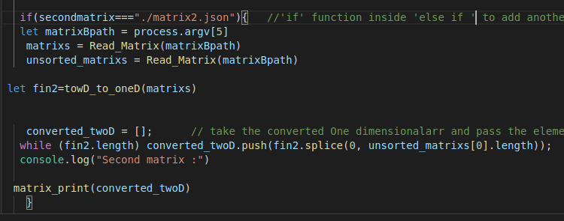Drawing 14: if function for second position in insertion sort

Array Insertion sort
- The command (node app.js ./array.json )
the basic deference between this operation and the insertion sort for matrix is the diension of the matrix. meaning here there is no need to convert the array to one dimension and reconvert it.
Drawing 15: insertion sorting of array
The operation type is ‘sort’. The insertion function is with in a for loop set to a limit of length of the array passing.
Since the position of the “arrayPath” is right after the ‘type’ it’s placed on process.argv[3]

Results
Matrix subtraction
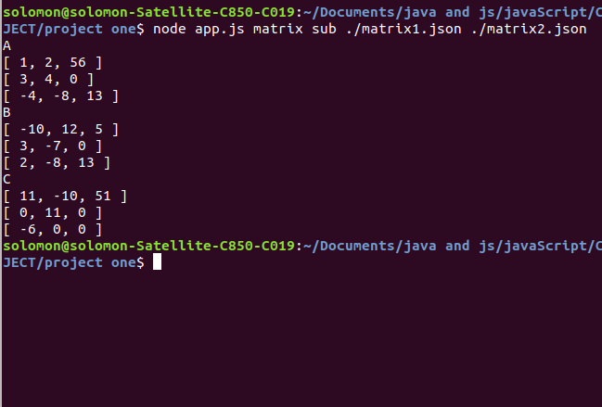Drawing 16: subtraction result
Matrix multiply
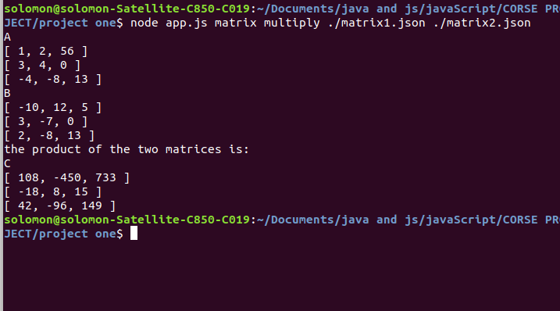Drawing 17: Matrix multiply result

Matrix Insertion
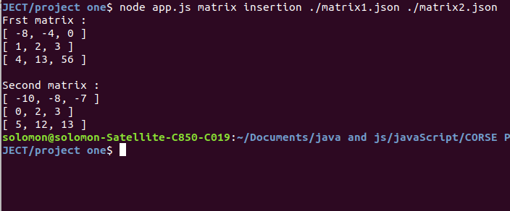Drawing 18: Two- Matrix insertion result
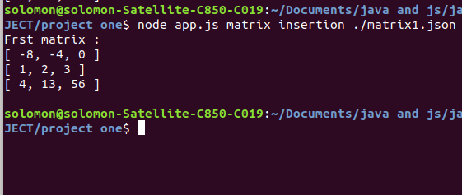Drawing 19: One-Matrix insertion
Array Insertion
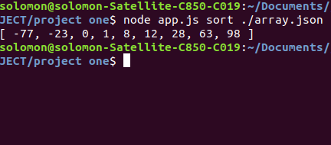Drawing 20: Array-Insertion

